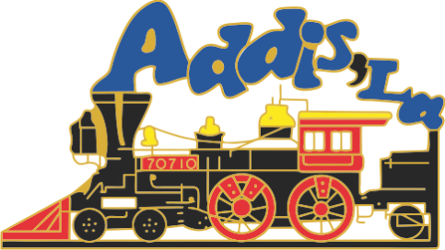

COV-19 Virus
3/26/2020

- In an effort to extend protection to Town of Addis Employees; the Addis Town Hall office will close at Noon on Friday, March 27th.
- Regular Town of Addis services with the lobby closed will resume Monday, March 30, 2020.
LA state wide 211 network is now answering calls about COV-19, Corona Virus. This network is best designed and staffed to answer all questions about the virus.
See the Town of Addis Website at www.addisla.org and click on the COVID-19-UPDATES in RED and/or see the Parish Website link on our page and click on the COVID-19 Red button for the latest updated information.
End

